**RAILWAY RESERVATION SYSTEM USING UIPATH STUDIO**

**CHARMINE MARIA THOMAS ,GUNASHRI S, JANANI A, SANTHANALAKSHMI S T**

**INTRODUCTION:**

The Railway Reservation System is a pioneering effort to modernize and streamline the ticket booking process for various stakeholders in the travel industry, such as travel agencies, corporations, and individuals. Leveraging UiPath, a leading Robotic Process Automation (RPA) platform, this project demonstrates the transformative potential of automation technology in addressing complex and repetitive processes. By automating bulk ticket reservations, the system eliminates manual efforts and ensures precision, speed, and convenience.

The automation process is built on a foundation of data extracted from Excel files, which serve as the primary data repository for passenger details, travel preferences, and other relevant information. The bot uses this structured data to interact with a web-based railway booking platform, validating each data entry to guarantee compliance with the platform’s requirements. This validation step is essential in maintaining accuracy, reducing errors, and ensuring that all necessary information is complete before the booking process begins.

Upon accessing the railway booking website, the bot initiates a series of automated actions to complete the ticket reservation process. The automation not only handles individual bookings but also manages bulk reservations seamlessly, offering a solution that is both scalable and efficient. Moreover, the bot enhances the passenger’s travel experience by integrating additional features, such as web scraping to collect curated information about the destination. These details, including a list of the top tourist attractions, are appended to a confirmation email sent to passengers along with their tickets.

The project also highlights the importance of operational reliability. By incorporating error-handling mechanisms and robust recovery strategies, the system ensures continuity and resilience even in the face of unforeseen challenges, such as website downtime or invalid input data. In essence, the Railway Reservation System leverages the power of UiPath to deliver a highly efficient, user-friendly, and reliable solution that meets the evolving needs of the travel industry.

**AUTOMATION PROCESS**

The Railway Reservation System's automation process is a multi-step workflow designed to deliver an efficient, accurate, and user-friendly ticket booking solution. Each stage of the process is optimized to reduce manual intervention, ensure data accuracy, and improve the overall user experience. This systematic approach is divided into three primary phases: data extraction, web interaction, and user communication.

**Data Extraction**

The first phase of the process focuses on extracting traveler details from Excel files. Excel serves as a structured and easily manageable format for storing passenger data, including names, Aadhar numbers, travel destinations, and preferences. The bot initiates this phase by accessing the Excel file using UiPath's "Excel Application Scope" activity, a feature designed to interact seamlessly with Excel files. Once the file is opened, the "Read Range" activity is employed to extract specific rows and columns of data, which are then stored in a DataTable format.

The bot processes each row of the DataTable using the "For Each Row" activity, ensuring that every passenger's data is validated and prepared for the booking process. Validation checks are crucial at this stage to confirm that all mandatory fields are complete and meet the required format. For example, Aadhar numbers are verified for correct length and numeric format, and destination entries are cross-checked against valid options. By performing these checks early in the process, the system minimizes the likelihood of errors during the booking phase.

**Web Interaction**

After data validation, the bot transitions to the web interaction phase. Using the "Use Application" activity, the bot launches a web browser and navigates to the railway ticket booking website. Here, it automates the following actions:

1. **Inputting Passenger Details:**  
   Passenger information, such as names, Aadhar numbers, departure points, and destinations, is entered into the booking form using the "Type Into" activity. This activity ensures that the data extracted from Excel is accurately transcribed into the corresponding fields of the web application, maintaining consistency and reducing manual errors. The process is dynamic, allowing the bot to handle various input formats while ensuring each field aligns with the website’s requirements.
2. **Selecting Travel Preferences:**  
   The bot efficiently manages dropdown menus for travel class and berth preferences using the "Select Item" activity. This feature guarantees that passengers' specific preferences are precisely reflected in their ticket bookings without requiring manual intervention. The automation is flexible enough to adapt to a variety of dropdown configurations, including complex multi-level menus, ensuring accurate selection. It also incorporates validation checks to confirm that the selected options align with availability and passenger input, ensuring a seamless user experience while adhering to the selected travel criteria. This reduces errors and saves significant time.
3. **Submitting Booking Requests:**  
   To finalize the booking process, the bot navigates through the website’s interface by employing "Click" and "DoubleClick" activities. These actions automate the submission of the booking form and efficiently handle additional steps required for confirmation, such as acknowledging pop-ups, verifying user inputs, or selecting payment options from various available methods. The bot ensures that each interaction with the website is accurate and timely, reducing the chances of incomplete or failed bookings. This approach guarantees a smooth, uninterrupted workflow while delivering consistent and reliable results across different booking scenarios, even under dynamic or complex web interface conditions.

Once the reservation is complete, the bot downloads the ticket file. This is achieved through another "Click" activity, which identifies and interacts with the download button on the website. The ticket file is saved to a predefined folder with an appropriate naming convention for easy organization and retrieval.

**Enhancing the Travel Experience**

Beyond booking tickets, the bot incorporates additional features to enrich the passenger’s travel experience. Using UiPath's web scraping capabilities, the bot performs a search for "10 best places to visit in [destination]". Relevant URLs are extracted and appended to a confirmation email, along with the passenger’s ticket details.

This email is composed using the "Send Email" activity, which dispatches the ticket and curated travel recommendations to the passenger. By including these personalized suggestions, the system not only meets the functional requirements of ticket booking but also adds value to the passenger’s journey by offering helpful travel insights.

**Error Handling**

A robust error-handling mechanism is integrated throughout the workflow to ensure uninterrupted operation and maintain system reliability. The "Try Catch" activity is employed to detect and manage potential issues such as invalid input data, website downtime, connectivity errors, or unexpected system failures. In the event of an error, detailed error messages are logged for troubleshooting, enabling quick identification of the problem's root cause. Furthermore, recovery steps are automatically initiated to resume the workflow from the last successful step, minimizing downtime and maintaining continuous operation. This proactive approach ensures that the system remains resilient, even in the face of challenges, and provides a seamless user experience.

In summary, the automation process is a comprehensive and meticulously designed workflow that integrates data extraction, web interaction, and user communication into a unified system. It not only streamlines operations but also enhances the passenger’s experience by delivering a seamless, personalized service. The combination of advanced automation techniques, flexible error-handling, and real-time adaptability makes the system both efficient and reliable, offering long-term value and operational excellence in ticket booking.

**FLOWCHART:**

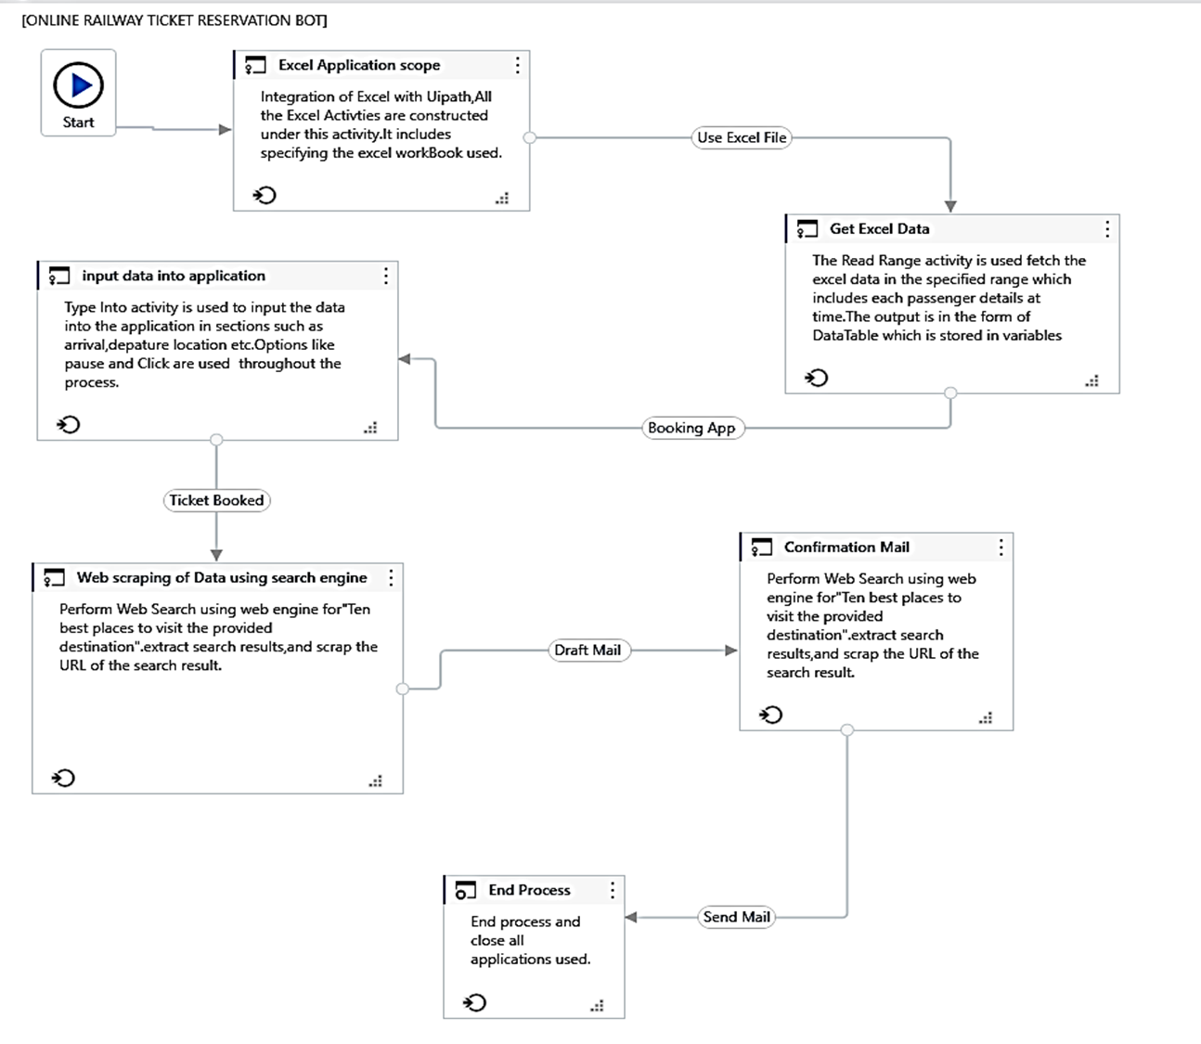

**CONCLUSION:**  
  
The integration of UiPath technology in the Railway Reservation System marks a significant milestone in modernizing the ticket booking process. By automating repetitive tasks such as data validation, web interactions, and email composition, the system delivers unparalleled efficiency, accuracy, and convenience. The use of advanced RPA techniques ensures that the booking process is not only fast but also error-free, eliminating the challenges associated with manual operations.

One of the standout features of this system is its ability to enhance the passenger’s experience by providing curated travel recommendations alongside their tickets. This thoughtful addition transforms a routine booking into a comprehensive travel planning service, adding significant value to the user. Moreover, the system’s scalability and flexibility make it an ideal solution for handling bulk reservations, catering to the needs of travel agencies, corporations, and individual users alike.

The incorporation of robust error-handling mechanisms further underscores the system’s reliability. By detecting and addressing issues in real-time, the system ensures uninterrupted operation and a seamless user experience. These features collectively position the Railway Reservation System as a benchmark for automation in the travel industry, offering a glimpse into the future of streamlined operations and enhanced customer satisfaction.

In conclusion, this project demonstrates the transformative potential of RPA in addressing the challenges of legacy systems. By modernizing the ticket booking process and delivering a reliable, user-centric solution, the Railway Reservation System exemplifies the value of automation in driving efficiency, innovation, and customer satisfaction in the travel sector.